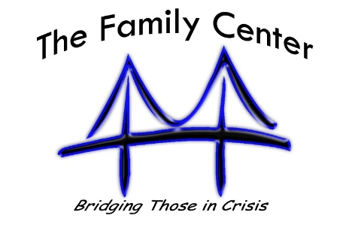
Family Center Confidentiality Policy
Employees, volunteers, and board members of South Central Family Center are bound by ethical and legal codes to protect the confidentiality and privacy of our clients and to protect and maintain the confidentiality of all information learned about clients, their family members and acquaintances in the course of providing services to them. Confidential communications include conversations, reports, forms, correspondence, and computer-generated communications with, about or involving in any way any client of South Central Family Center. Minors are entitled to confidentiality also, and only the guardian of the minor can waive the confidentiality. Access to documentation shall be limited to an “as needed/need to know” basis.

Storage of Records
South Central Family Center and its employees have an ethical and legal obligation to respect the privacy of our clients, and to protect and maintain the confidentiality of all information that we obtain about clients, their friends, acquaintances and family members in the course of providing services to them. Client records are legally protected confidential records and must be treated as such. This means that client records maintained by South Central Family Center must be always kept in the locked file room except when being reviewed or updated. Client records should always be maintained in office only. It is unethical to discuss clients with family or friends, unless you are ordered to do so by a court or otherwise required by law. If someone insists on obtaining information and the client has not authorized it, immediately notify the Executive Director.

Areas of Confidentiality
Confidential communications include conversations, correspondence, forms, reports and computer-generated communications with, about, or involving in any way any clients.

Client confidentiality will be broken only under certain conditions.
- When the client is a threat to others or self. Under TN law, if you have any reason to suspect a child is being sexually, physically, or psychologically abused or neglected, then you are required to report the situation to Child Protective Services.
- If client files are subpoenaed.

Sharing of Information
There are times we must share information with other partner agencies in order to obtain additional services or to better serve the client. This can only be done if it is an accredited partner/agency and when the client has signed a release of information as part of the application process.

Sharing of Information
Obvious, deliberate and conscience breach of the South Central Family Center confidentiality policy will result in immediate dismissal and depending on the type of occurrence could result in criminal charges.

